Validation Rules Solution

Exercise 1: Investigation

In this exercise, you create two maturity validation rule sets and observe their effects.

For the sake of reference, the five maturity validation levels in the base application, in order, are:

* Loadsave
* New Loss Completion
* Valid for ISO
* Send to external (system)
* Ability to pay

1. Inside the **Claim Validation Rules** rule set, enter the following rule:

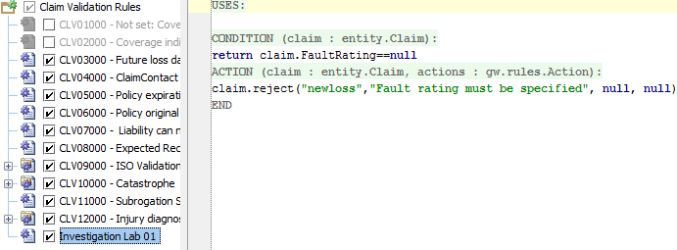

* 1. Will this rule raise a warning? If so, at what maturity level? No.
  2. Will this rule raise an error? If so, at what maturity level? Yes, newloss.

1. You do not need to test the rule at this point**.**
2. Inside the **Claim Validation Rule** rule set, enter the following rule:

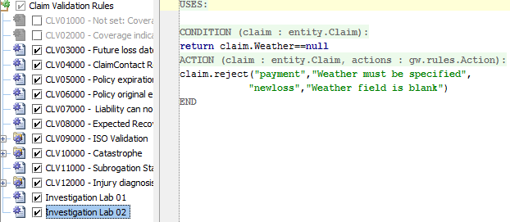

* 1. Will this rule raise a warning? If so, at what level? Yes, newloss.
  2. Will this rule raise an error? If so, at what level? Yes, payment.

(You do not need to actually test the rule at this point.)

1. Create a new auto claim. On the **Loss Details** step, leave both the **Fault Rating** and **Weather** fields blank.
   1. Can you save the claim? No.
   2. Are both validation messages displayed? Yes.
2. Specify the **Fault Rating** as No fault and save the claim.
   1. What is the claim's validation level? Send to external system.
   2. How did the claim get beyond new loss completion? It satisfied all the rules of that level as well as the next two. Therefore, it was promoted to "Send to external system".
   3. Why isn't the claim at ability to pay? It does not yet meet all the rules to reach that level.
3. For the saved claim, attempt to set the **Fault Rating** back to none selected. What happens? Why? The save cannot be made. This is because the claim is passed "new loss completion" and cannot violate any of the conditions at that level.
4. Using the claim's **Actions** menu, validate the claim at new loss completion. Then, validate the claim at ability to pay. Were the validation results the same? No. The validation at "new loss completion" produced only the warning message about weather. (The claim met all other conditions.) The validation at "ability to pay" displays the **error** message about weather.
5. Change the claim's **Weather** field to Clear. What is the claim's validation level now? Ability to pay.
6. Disable the two rules you created at the start of the lab. (This prevents them from interfering with work you will do later in the course.)

Exercise 2: Configuration

Configure ClaimCenter to meet the following customer requirement from Acme Insurance.

Requirement 1: Validation for Claim Fields

Acme Insurance has the following requirements for claims:

Claim - new loss completion

* If the loss cause is either "Theft Audio or other parts" or "Theft of entire vehicle", there must be at least one police report listed. (Police reports are listed in the Metropolitan Reports list on the Loss Details page.)
* If the Fault Rating is "no fault" and the loss location's state is California (CA) or New York (NY), warn the user that the given state is not a "no fault" state, but let the claim be saved.

Claim - valid for ISO

* The claim must have a description. Highlight the field.

1. Write the claim validation rule(s) needed to enforce the behavior above.

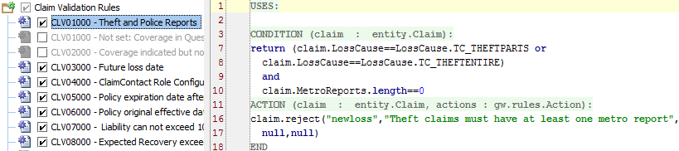

CONDITION:

return (claim.LossCause==LossCause.TC_THEFTPARTS or claim.LossCause==LossCause.TC_THEFTENTIRE) and claim.MetroReports.length==0

ACTION:claim.reject("newloss","Theft claims must have at least one metro report", null,null)

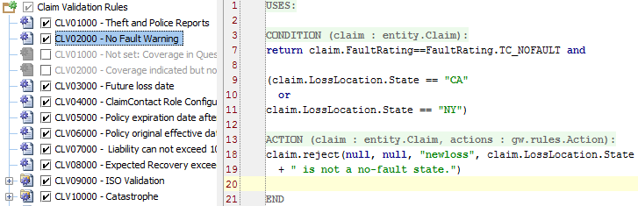

CONDITION:

return claim.FaultRating==FaultRating.TC_NOFAULT and

(claim.LossLocation.State == "CA"

or

claim.LossLocation.State == "NY")

ACTION:

claim.reject(null, null, "newloss", claim.LossLocation.State

+ " is not a no-fault state.")

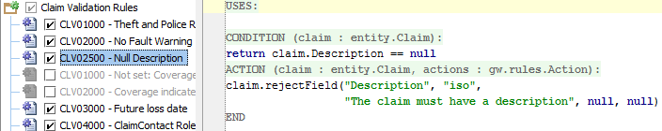

CONDITION:

return claim.Description == null

ACTION:

claim.rejectField("Description", "iso",

"The claim must have a description", null, null)

Bonus Task

Requirement 2: Validation for Exposure Lists

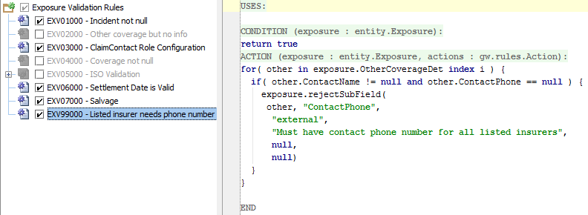

CONDITION:

return true

ACTION:

for( other in exposure.OtherCoverageDet index i ) {

if( other.ContactName != null and other.ContactPhone == null ) {

exposure.rejectSubField(

other, "ContactPhone",

"external",

"Must have contact phone number for all listed insurers",

null,

null)

}

}